Lab5 Deliverables

- Objectives
To implement a rudimentary file system on an SD card by writing efile.c and efile.h, given the low lever disk access routines as part of edisk.c and edisk.h.
- Hardware Design
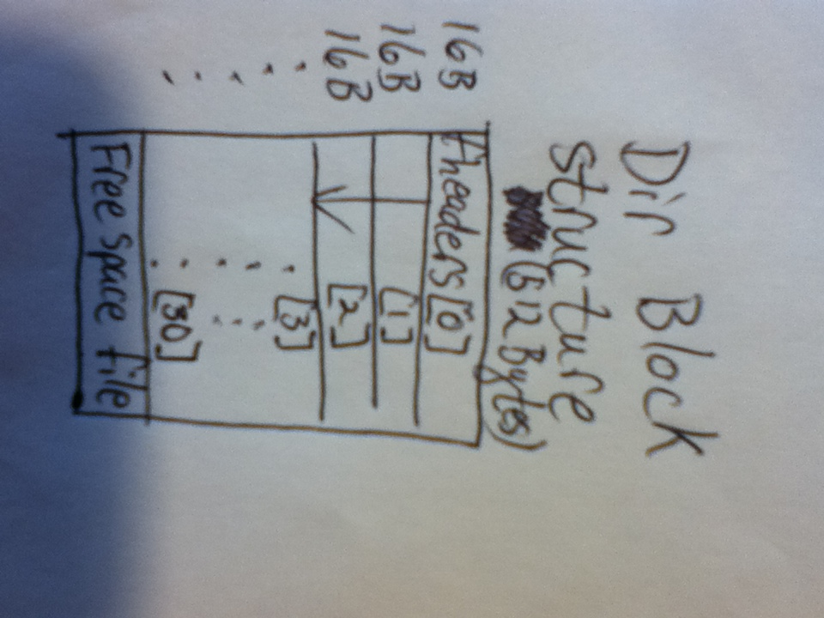
There was none, move along, nothing to see here…
- Software Design
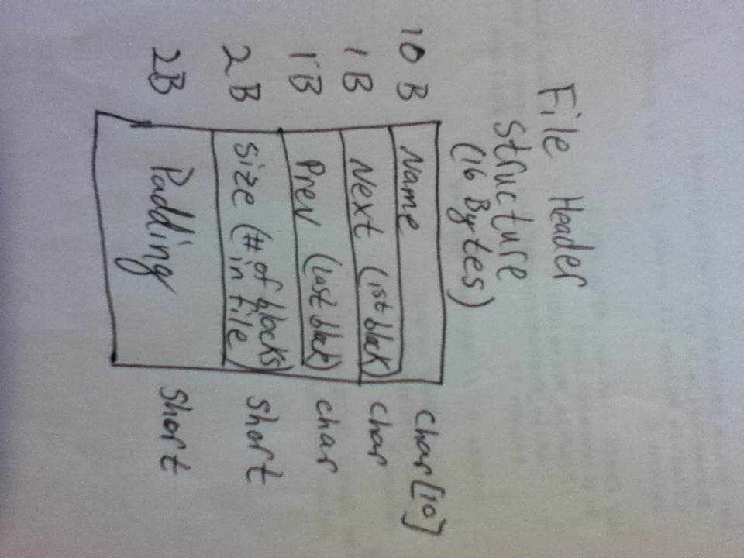
- Illustrations:
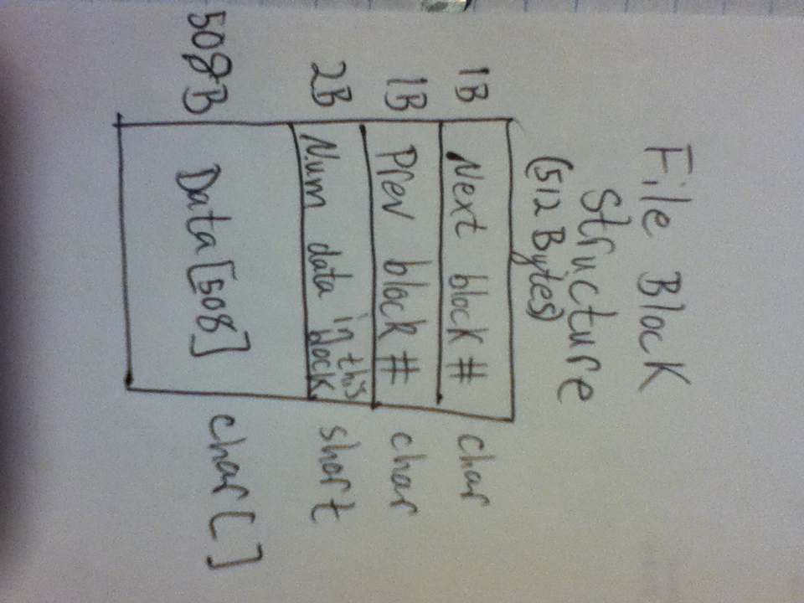
The free space allocation works just like the normal file headers, it is the last index of the DIR Block, where the Next pointer points to the beginning of the free space list, and the prev pointer points to the end of the free space list. Each block in the free space list is linked to the prev and next block in the list during the format function.

- See attached eFile.c and eFile.h
- Interpreter commands were not implemented for this lab, we have decided to not use this as part of our final file system so we stopped half way through.

- Measurement Data
  - //TODO
  - //TODO
  - //TODO

- Analysis and Discussion
  - No, our implementation is done via linked list, so every block gets used, there is internal fragmentation, but no external.
  - Half the storage would be wasted; if we choose random numbers then it is likely that for every number above the half way mark there is an equal to counter it below the half way mark.
  - I would expect the bandwidth to be a hellofa lot faster, limited probably by the speed of the bus on our microcontroller.
  - 31 file headers, plus 1 free space header. To increase this number I could either decrease the number of characters used for unique representation, or expand the index table across multiple blocks.
  - Ours does allow it, but is not supposed to. Again, we didn’t care to implement the semaphores because we aren’t going to use this system in the end. We could have enabled it by putting a semaphore only around the function that writes and using local variables for the unions for the read and write instructions. Also we would have to force each write instruction to read the DIR Block when it started it’s write, and write it back when it was either finished or interrupted.

